**PROGRAMS :**

//write a c program to implement linear search with functions

//Ethan Menezes 21co24

#include<stdio.h>

void isfound(int [],int); //function declaration

int main()

{

int array[20],size; //declaring variables

printf("Enter the size of array \n");

scanf("%d",&size);

printf("Enter the elements \n");

for(int i=0;i<size;i++)

{

scanf("%d",&array[i]);

}

isfound(array,size);//function call

return 0;

}

void isfound(int array[],int size) //function definition

{

//logic to find the number in the array

int found=0,number;

printf("Enter the element to be found \n"); //Enter the number to be found

scanf("%d",&number);

for(int i=0;i<size;i++)

{

if (number==array[i])

{

printf("found the element %d at location %d",number,i+1);

found=1;

break;

}

}

if(!found)

printf("Element not found\n");

}

OUTPUT:

Successful

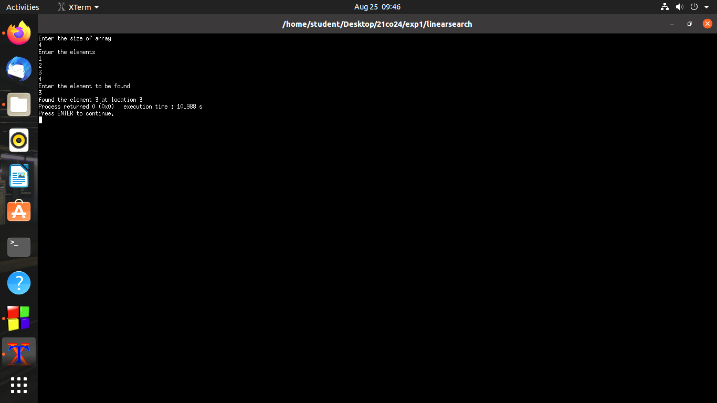

OUTPUT:

Unsuccessful

